APSC496

Project Proposal

**Praxim Surgical Robot**

**Team Members:**

Nicolas Adams

Davy Chiu

Ibrahim Gadala

David Mountford

Erica Wodzak

**Date Submitted:**

October 13, 2009

**Word Count:**

2503

**Abstract**

This proposal outlines the need, market, requirements and suggested work plan for the redesign of a 3D haptic interface for Praxim in preparation for cadaver testing. The main goal of this project is to improve the initial prototype, in such areas as: size, weight and the ability to sterilize. The need for this product is to speed up bone shaping operations, while minimizing tissue damage. The projected market is large hospitals and their surgeons that perform a high volume of orthopaedic surgeries. The requirements are to reduce size and weight while also making the device easily sterilized. Deliverables include the following reports: project proposal (Oct 13th, 2009), reference reports (Oct 19th, 2009), concept report (Nov 9th, 2009), critical function prototype report (Nov 30th, 2009), conceptual alternative choice report (Jan 8th, 2010), technical analysis report (Jan 25th, 2010) and final report (April 19th, 2010). As well as these reports, a working prototype will also be delivered.

**Table of Contents**

1. Introduction 1
   1. Stakeholders 1
   2. Projected Market 2
2. Requirements and Evaluation 3

2.1 Problem Statement 3

2.2 Requirements 4

2.3 Evaluation Criteria 6

1. Work Plan 7

3.1 Initiation and Planning 8

3.2 Specifications 8

3.3 Conceptualization and Design 9

3.4 Prototyping 9

1. Roles of Team Members 10
2. Resources Required 11

5.1 Currently Available 11

5.2 Need to Acquire 12

5.3 Financial Requirements 13

6.0 References and Appendices 14

6.1 References 14

6.2 Appendix A – Gantt Chart 15

**1.0 Introduction**

Praxim, a company based in Grenoble, France, currently markets computer-assisted surgical systems for orthopaedic surgery. One of these products is Praxiteles, which is a single dimensional surgical robot that aids surgeons in making planar bone shaping cuts during total knee replacement (TKR) surgeries.

The next phase in the development of Praxiteles is to have a haptic interface that successfully emulates a 3-dimensional hard surface. The first step toward this goal was a achieved by a UBC graduate student, Nikolai Hungr, who developed a 2-dimensional haptic constraining system. The next step was taken by a team of UBC mechatronics students who were able to build an initial prototype of the desired 3-dimensional haptic interface.

The goal of this project is to improve the previous prototype order to make the device smaller, lighter and able to be sterilized. The function of this device will be to provide a 3-dimensional, constantly adapting set of constraints that will guide the surgeon in performing quicker and more accurate bone shaping operations; therefore, reducing surgery times while minimizing tissue damage.

**1.1 Stakeholders**

The primary stakeholders for this product are hospitals and their orthopaedic surgeons. Hospitals will benefit from this product by moving patients through the operating room (OR) more quickly; therefore, allowing surgeons to perform more surgeries while reducing OR operating costs. The surgeons will subsequently be able to perform more precise procedures without having to worry about causing significant tissue damage. Surgeons also my benefit financially by performing more procedures in a day.

Secondary stakeholders for this product are the patients, whose recovery time will be decreased (again, due to minimal tissue damage). Furthermore, as the number of procedures performed daily should increase, the waiting times for a TKR procedure should decrease.

Tertiary stakeholders may be rehabilitation facilities and home caretakers, who will work with patients to regain their full mobility and independence; as recovery time is likely shortened, this will allow them to process more patients as well.

**1.2 Projected Market**

As there is not currently a product with similar functionality to Praxiteles or this expansion project on the market, there is a great market opportunity. Praxim’s target market for this device is the network of high-volume arthroplasty hospitals, performing multiple TKR procedures per day.

There are a number of improvements that must first be made to the existing prototype before this product can be marketed, or even cadaver tested. First, the robot’s size must be decreased, and subsequently its weight must also be decreased, as it is a bone-mounted device and cannot put excessive forces on the bone during the operation. Second, the device must have complete 3D capability, which will allow for fluid performance; a 2D device is somewhat beneficial, but does not provide enough worth to be practically marketed, as the surgeons must constantly adjust the device for each new cut location.

It can be concluded that this device, with full 3D functionality, will provide enough value to all stakeholders to justify its purchase and subsequent use because there is currently no similar technology on the market. This product could potentially be seen a successful disruption into the TKR surgical device market.

**2.0 Requirements and Evaluation Criteria:**

**2.1 Problem Statement**

“Refining specific hardware & software components of an existing 3D Haptic Interface, based on client feedback, to produce a prototype that will be ready for cadaver testing”

**2.2 Requirements**

The inputs of the interface are as follows:

* A power source, required for the operation of all electrical components
* The computer-generated data of the 3D surface to be shaped
* User-applied forces, which move linkages and the cutting tool

The outputs of the interface are as follows:

* The feedback that the device provides to the user (in the form of a virtual surface constraint)

This project will have a set of requirements that come from either the previous iteration of the project and its prototype, from client feedback regarding current issues with the existing prototype, or completely new concepts/requirements developed by the current design team. The following are the design requirements for the 3D Haptic Interface Device:

|  |  |  |  |  |
| --- | --- | --- | --- | --- |
| **#** | **Design Module** | **Requirement Type** | **Design Requirement** | **Rationale** |
| 1 | System | Functional | Device provides a hard constraint when the user pushes the tool beyond the operational boundary (minimum resistance of 10kN/m) | This is the product concept |
| 2 | System | Functional | The tool, when mounted on the device, is able to make both curved and planar cuts in 3-dimensions | This is the product concept |
| 3 | System | Functional | System constantly monitors position of device and cutting tool | This allows the device to properly respond to user movements |
| 4 | System | Functional | Device’s hard surface constraint must be physically imposed within 0.5mm of the desired model surface | This provides accurate and aligned surgical results |
| 5 | System | Functional | Device must facilitate the drawing of 3D shapes unique to each surgery generated by the user. | Facilitates performing unique surgeries for a wide variety of different implant shapes and sizes |
| 6 | System | Interface | Device must be able to be solidly mounted on bone/knee during surgery, completely secured with minimal movement (+/- 0.5mm) | Required for ensured safety of system, minimizing tissue damage, allows surgeons to be confident in positioning |
| 7 | System | Interface | Device must be capable of being sterilized (steam at 134°C) without deteriorating materials and/or components | Allows surgeon/surgical staff to maintain the sterile area while the device is in use, and allows for multiple uses |
| 8 | System | Interface | Any un-sterilizable components must be completely and sealed and contained in a sterilizable encasement | Allows surgeon/surgical staff to maintain the sterile area while the device is in use, and allows for multiple uses |
| 9 | System | Ergonomics | Device must be small/compact enough to both fit into a standard hospital-sized autoclave and be mounted to the operating location without impeding the user’s access. | Allows for easy sterilization, and is less cumbersome for surgeons to work with |
| 10 | System | Ergonomics | Device must be light-weight, weighing less than 10 lbs in total | Minimizes external forces applied to surgical area |
| 11 | System | Ergonomics | Device must have a resistance to user-directed movement less than a virtual weight of 1 kg | Ensure that movement is not difficult to achieve and easily follows the surgeon’s directions. |

**2.3 Evaluation Criteria**

The impact of the requirements mentioned above on the user depends on immediate needs or priorities versus preferences. The main priority for the user lies in the sheer functionality of the device – in its immediate performance. In simple terms, the device must be accurate, smooth, and easy to operate. Satisfaction curves for “functional” evaluation criteria are thus expected to be sharp, as the user will never be satisfied with less performance for the device. This trend will be less profound in interface requirements, since users are generally willing to sacrifice small additional functions without much dissatisfaction. The following descriptions present the reasons why the requirements stated earlier are considered priorities. Also, satisfaction curves for major requirement criteria are provided.

**Tool Position Instability:**

A user expects that vibrations and roughness which commonly occur at sharp corners in the desired surface to be reduced. Practically, these areas in the surface are critical to the success of the entire surgery altogether. Thus, in order to satisfy the user (surgeon and ultimately, the patient), a strict limit of 1 mm was chosen for the radius of inaccuracy in areas of high instability. Similarly, maximum satisfaction occurs when there is no instability present (radium = 0), and radii above 2 mm will be deemed as unsatisfactory.

**Surface Shape Acquisition Method:**

This desired surface to be shaped is the main input into the device, thus, making this method of input easier on the user has a very high impact on the user’s satisfaction. Currently, there are only three basic shapes possible for the user to choose from. In order to sufficiently satisfy the user, shapes must not be imposed on them; rather, they should be able to generate the shapes they would like to implement. An interface with the ability to process the desired shapes of a user, provided they are in mathematical equations, will sufficiently satisfy the majority of surgeons on the market. For utmost satisfaction, this interface can be upgraded to immediately be able to process any 3-D computer file of the shape, for example, from a CT scan or a CAD program.

**Total Device Weight:**

The overall weight of the device is crucial to reduce, for a variety of reasons. Most importantly, a heavy device might not be mountable on the femur during the surgery due to its excessive weight. Even when mounted, any misalignment or movement by a heavier device continually creates larger forces and stresses on the existing bone, an occurrence which can lead to complications in tissue healing. Finally, a lighter device is easier for clinical staff to carry, transport, clean, and sterilize. Thus, weight is considered to be a high-impact requirement on user satisfaction.

**Resistance to Motion (*virtual* weight):**

It is important to reduce the total weight of the device, but it is equally important to minimize the “virtual weight” the user experiences when operating the device. Surgeons want a device which operates smoothly and follows the natural movements of their hands with the least resistance. This is a high-value priority for the new design, as it directly impacts the main function of the device. In order to quantify *virtual* weight, we used our knowledge of *actual* weights which normal human hands can operate under with ease and low resistance motion. To sufficiently satisfy the user, this *virtual* weight should fall between 1 and 2 pounds, with anything under 1 pound being maximally satisfactory, and anything above 2 pounds being unsatisfactory.

# 3.0 The Work Plan

The Praxim Surgical Robot project has been split up into four phases and a list of tasks that span next eight months is shown in **Error! Reference source not found.**. The phases are as follows:

* Initiation and Planning
* Specifications
* Conceptualization and Design
* Prototyping

## 3.1 Initiation and Planning

Initiation and planning has begun and is critical to the overall structure of the project. Here the project team will develop a list of actions that must occur to meet our project goals. Team structure and roles are already in place and the work plan has assigned all resources to the development of detailed goals in five areas until October 30th. The topics are:

* Device performance (relating to the characteristics of the 3D surface created by the device)
* User interface (how the user interacts with the device)
* Size and sterilization (will the device fulfil medical requirements to be used in surgery?)
* Manufacturing (how will manufacturing figure into the design decisions?)
* 3D surface generation (how will surface model be input into the device?)

Two milestones are included in this phase, the project proposal due on October 13th, 2009 and the reference report due on October 19th, 2009. highlights the projects milestones and their timing.

## 3.2 Specifications

In specifications the team will focus on converting the qualitative goals outlined in the planning phase into a list of quantitative requirements and specifications. These tasks require the completion of background research and project goals from the planning phase and are split into the same five topics outlined above. No milestones are specifically related to the specifications phase, but tasks must be completed before the concept report, due on November 9th, 2009.

## 3.3 Conceptualization and Design

With a detailed understanding of what project aims to achieve the team will progress to focus satisfying these requirements through concept generation and detailed design – the specifications phase must be completed before concept generation can begin. After initial concept generation and evaluation the team will identify the critical function and proceed to design and construct a prototype that facilitates this function. The prototype is required for the critical function prototype report due November 30th, 2009.

Design for the remainder of the device will be completed between early December and late January noting that limited progress will be made during the exam period in December. Two other milestones are included in this phase, the conceptual alternative choice report due January 8th, 2010 and the technical analysis report due January 25th, 2010. A more detailed breakdown of the design tasks will be created once the final concept is defined.

## 3.4 Prototyping

Aside from the critical function prototype described above, a functioning surgical robot will be constructed and tested in this project. The prototyping phase includes all manufacturing and assembly required as well as the development of tests to evaluate the design based on the specifications identified in phase two. A final report describing these findings will be completed for the final report milestone due April 19th, 2010. Some prototype work will be completed alongside conceptualization and design, especially during the development of the critical function prototype.

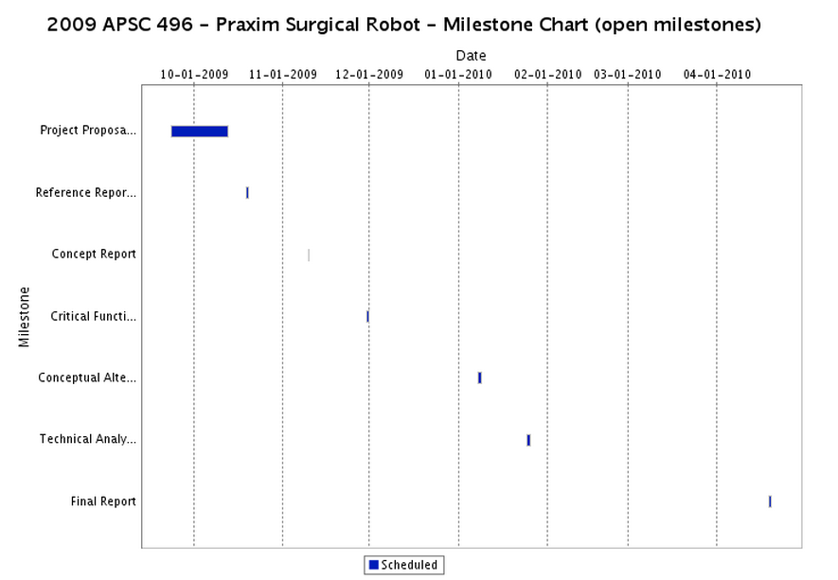

Figure 1 - Milestone Chart for Praxim Surgical Robot project

# 4.0 Roles of Team Members

In order to complete this project in an efficient and effective manner, each group member has taken on aspects of the project that they will be responsible for. These responsibilities are as follows:

Nicholas Adams – Project Coordinator and Assistant Liaison

Erica Wodzak – Liaison and Assistant Project Coordinator

David Mountford – Editor and Drawing Manager

Davy Chiu – Financial Manager

Ibrahim Gadala – Technical Manager

# 5.0 Resources Required

## 5.1 Currently Available

The following contacts will be consulted throughout the duration of this project.

Christopher Plaskos is the client of the project and will act as our main point of contact. We have gathered an idea of the requirements of the project from our telephone conversation.

Christopher Plaskos

christopher.plaskos@praxim.com

Dr Antony Hodgson is the supervisor of the project and will offer guidance throughout.

Dr Antony Hodgson

ahodgson@mech.ubc.ca

The prototype from last year is available as a reference and resource for our designs. Brad Roger, a member of last year’s Praxim group, will be our main contact for any technical information regarding the robot.

Brad Roger

778-552-7388

bradroger@gmail.com

An interview and a possible visit to Vancouver General Hospital to observe a TKR surgery with orthopaedic surgeon Dr Greidanus is currently being pursued. Erica is acting as liaison.

## 5.2 Need to Acquire

The following section briefly outlines some resources that will be critical to acquire for this project to be successful.

Current Prototype Analysis

The performance of the current prototype has yet to be quantified. We will need to measure all relevant performance data.

Praxim Bone Mount

Since the size of the bone mount and its loading capacity will dictate our designs, working with a Praxim bone mount would be ideal.

Test Subjects

The project will be tested ideally by surgeons for feedback regarding performance and usability. All external test subjects will require ethnical review.

Medical Standards

To ensure our designs will be suitable for surgery, our robot and processes will conform to the following standards: ISO 13485, MDD 93/42/EEC. UBC Library will offer a license for the ISO standard. The MDD standard is available on their website.

**5.3 Financial Requirements**

Dr Antony Hodgson has generously agreed to sponsor the financial expenditures for the project with research grants.

Table 1 and table 2 show an early estimate of the projects cost.

|  |  |
| --- | --- |
| Dremel Tool | $100 |
| Dremel Flex Shaft Attachment | $40 |
| Foam | $10 |
| Animal Bones | $20 |

Table 1 - Estimated cost of tools

|  |  |
| --- | --- |
| Motor | $200 |
| Encoder x2 | $100 |
| Electronics | $200 |
| Bearings | $50 |

Table 2 - Estimated cost of parts

**6.0 References and Appendices**

**6.1 References**

1. Mech451/2 Praxim Project Final Report, 2008

2. Haptic Emulation of Hard Surfaces with Applications to Orthopaedic Surgery, Nikolai Hungr, 2008

**6.2 Appendix A - Gantt Chart**

